How to check PecStarWeb V3.5 WebClient
- Open Control PanelAdministrative Tools, double-click Internet Information Services (IIS) Manager.
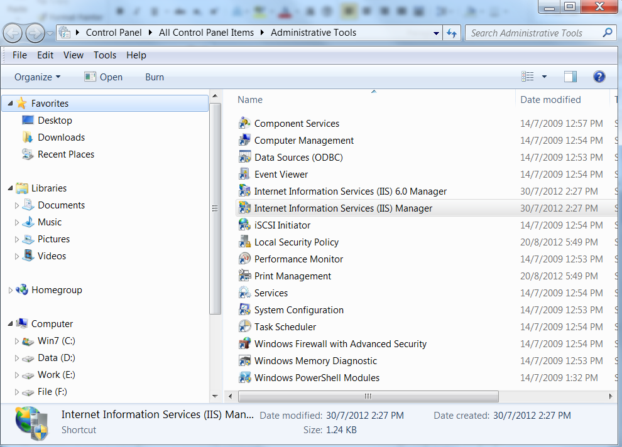
- The Internet Information Services (IIS) Manager window appears. Expand Computer NameSites, find PecStarWeb, right-click on it, select Manage ApplicationBrowse.
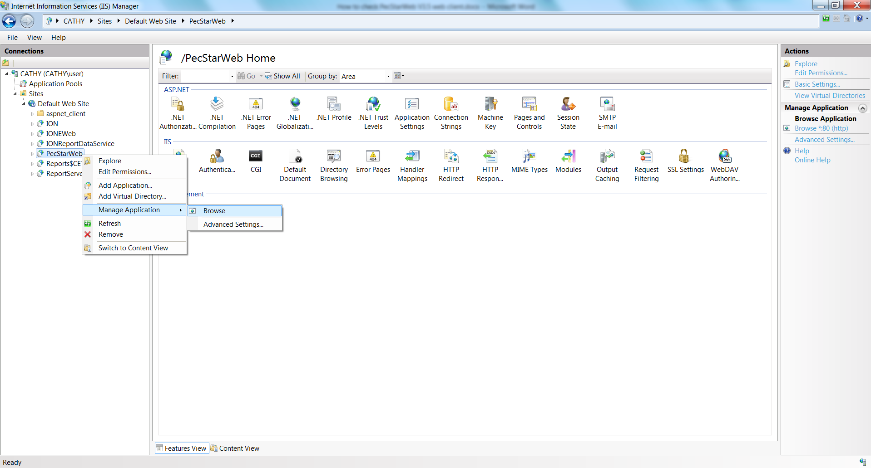

- Click StartRun, enter cmd. Then turn to the webclient folder, and enter regsvr32.exe webviewctrl.ocx. As below.
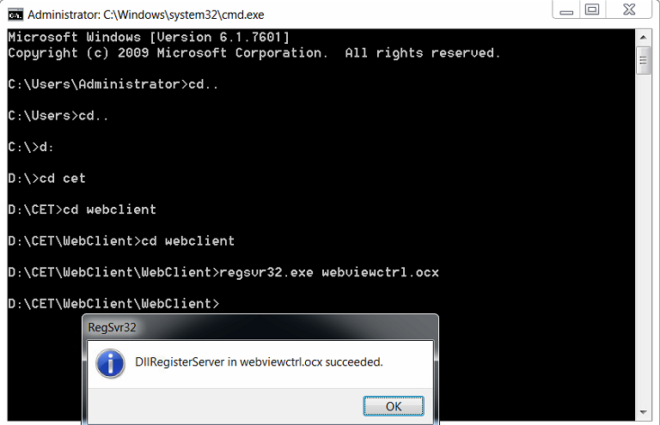
- Click StartRun, enter iisreset. Then open PecStarWeb website.

